Review of 2nd Corinthians (Sermon)

Intro—Paul the Humble Servant (Worldly Success is not the Same as Godly Success)
The Corinthians had not taken heed to Paul’s first letter, due to the fact that they questioned his authority. They questioned it because he didn’t seem successful enough to be a legitimate apostle. To them, respectable teachers had similar accomplishments as worldly leaders.
Week 1—Sincerity and Authenticity are crucial in the Christian life
Paul declared his sincere love for the Corinthians which was an important qualification for those who led and taught.
Week 2—As Christians, to some, we will smell sweet to others repulsive
To those who are seeking help in their brokenness the gospel will be like a breath of fresh air. To those who are bent on their own strength the message of Christ will seem weak and foolish.
Week 3—There is a difference between self-confidence and confidence in the gospel
We cannot and do not save ourselves and in fact none of our goodness is due to our own glory.
Week 4—The Old Covenant was only a shadow of how glorious God is
No one was ever saved by keeping the Old Covenant. The Old Covenant seemed like it could be kept, but God’s righteous standards are deeper and more glorious than any human can keep.
Week 5—God’s glory shines out in spite of our humanness
Even though our humanness keeps us from living up to God’s glory, through Christ, God made a way for His beauty to be seen through us.
Week 6—Our Fear of God’s Judgment should lead us to share Christ with others
As those who have trusted in Jesus we have no fear of God’s judgment. But our knowledge of God and our love for others should lead us to share the saving gospel of Christ with them.
Week 7—Since Christ has reconciled us to Himself, we should work to bring reconciliation to others
Our right relationship with God (the one Christ purchased for us) should inspire us to be in right relationship with others and give us a desire to see them in right relationship with God.
Week 8—As Christians our deepest commitments should be made with other believers
Since our destiny is doing the good works that God planned for us and growing in holiness our main partners in life should be those who are headed in the same direction.
This brings us to 2nd Corinthians chapter 7 in which Paul writes:
7 Because we have these promises, dear friends, let us cleanse ourselves from everything that can defile our body or spirit. And let us work toward complete holiness because we fear God.
2nd Corinthians 7:1 NLT
Before moving any further we need to go back and see what “promises” Paul is talking about. He finished chapter 6 with God’s word to the people who are known by His name.

“I will live in them
and walk among them.
I will be their God,
and they will be my people.
17 Therefore, come out from among unbelievers,
and separate yourselves from them, says the Lord.
Don’t touch their filthy things,
and I will welcome you.
18 And I will be your Father,
and you will be my sons and daughters,
says the Lord Almighty.”
2 Corinthians 6:16-18 NLT
We are to be different from unbelievers. We should say different things, act differently, and spend our time on different pursuits. If our definition of a successful life is different than an unbelievers definition of a successful life it is logical that our life will look different. Peter wrote of the same principle when he wrote:
7 Yes, you who trust (Jesus) recognize the honor God has given him. But for those who reject him,
“The stone that the builders rejected
has now become the cornerstone.”
8 And,
“He is the stone that makes people stumble,
the rock that makes them fall.”
They stumble because they do not obey God’s word, and so they meet the fate that was planned for them.
9 But you are not like that, for you are a chosen people. You are royal priests, a holy nation, God’s very own possession. As a result, you can show others the goodness of God, for he called you out of the darkness into his wonderful light.
10 “Once you had no identity as a people;
now you are God’s people.
Once you received no mercy;
now you have received God’s mercy.”
11 Dear friends, I warn you as “temporary residents and foreigners” to keep away from worldly desires that wage war against your very souls. 12 Be careful to live properly among your unbelieving neighbors. Then even if they accuse you of doing wrong, they will see your honorable behavior, and they will give honor to God when he judges the world.
1 Peter 2:7-12 NLT
The target you want to hit will dictate where your aim will be.
Let me use athletes as an example.
Who do you think has better physical fitness? Or maybe a better question would be who is a better athlete?
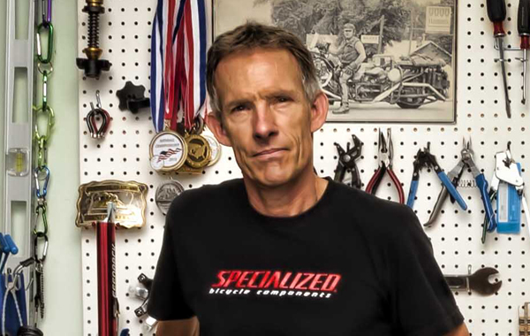

The answer is dependent upon what kind of event you were going to. If it is arm wrestling, football, weight lifting, a fist fight the nod would definitely go to JJ Watt. But the old guy in the first photo is Ned Overand, one of my favorite cyclists. He is currently 67 years old and he would destroy JJ Watt in any kind of bicycle race.
These two athletes have very different training goals and two very different body types. As Christians, our goals and the training we do should lead to stark differences in the way we look to the world. It’s not because we are weak or insignificant. It is because our life is not our own, we have been set apart to God to live for Him and His glory. This is the principle that Paul is trying to convey to the Corinthians. The ways of God are different from the ways of men.
It is hard, because to most people, the way of worldly success is highly appreciated. Not only are JJ Watt’s biceps bigger than Ned Overend’s, He probably has a much bigger bank account, as well.
The Corinthians had a hard time buying in to what Paul was selling. So he continued to plead with them. And he believed that they would come to see things through God’s lens. He goes on to say:
2 Please open your hearts to us. We have not done wrong to anyone, nor led anyone astray, nor taken advantage of anyone. 3 I’m not saying this to condemn you. I said before that you are in our hearts, and we live or die together with you. 4 I have the highest confidence in you, and I take great pride in you. You have greatly encouraged me and made me happy despite all our troubles.
2 Corinthians 7:2-4 NLT
It appears, by what Paul writes next, that at least some of the Corinthians responded with repentance.
5 When we arrived in Macedonia, there was no rest for us. We faced conflict from every direction, with battles on the outside and fear on the inside. 6 But God, who encourages those who are discouraged, encouraged us by the arrival of Titus. 7 His presence was a joy, but so was the news he brought of the encouragement he received from you. When he told us how much you long to see me, and how sorry you are for what happened, and how loyal you are to me, I was filled with joy!
8 I am not sorry that I sent that severe letter to you, though I was sorry at first, for I know it was painful to you for a little while. 9 Now I am glad I sent it, not because it hurt you, but because the pain caused you to repent and change your ways. It was the kind of sorrow God wants his people to have, so you were not harmed by us in any way. 10 For the kind of sorrow God wants us to experience leads us away from sin and results in salvation. There’s no regret for that kind of sorrow. But worldly sorrow, which lacks repentance, results in spiritual death.
2 Corinthians 7:5-10 NLT
For an athlete, who has been putting their heart, mind and body into training, it is disastrous to find out that they have been doing the wrong kind of training. If JJ Watt trained like Ned Overand or if Overand trained like JJ Watt it would actually damage their results in their given disciplines. And when they realized it they would have the opportunity to either change their ways or suffer the consequences.
Today I am going to use Paul’s writing to the Corinthians to encourage you to put your efforts into the things God has set us apart for instead of the things the world values. Let us all take stock in what we put our time in to.
Thick bank accounts and big biceps are really cool, but they really aren’t what the Christian life is all about. It is true that it isn’t impossible to have both, I’m simply encouraging us to ask the question:
“What are we putting our time and energy towards?” If it is mostly towards the things of the world, then we need to change up our training.

