Obsolete View of Glory
Selected Verses

What do VHS tapes, pay phones, floppy discs, vinyl records, fax machines, overhead projectors, typewriters, and fax machines all have in common?
They all had a new technology come along and make them obsolete. Something was made that did the same thing, and more, more effectively. They were a less glorious shadow of the new product.
I’m not saying that vinyl records aren’t cool and I’m not saying that they don’t get the job done. I’m just saying that they are great grandparents in the family tree of sound recording.
Let me pose another example. If you were a formula 1 car racer getting ready for the next big race, which of these vehicles would you want to line up in?
This…
Or this…

If you want to win, I think there is only one correct answer. The older car was a shadow of what formula 1 cars would become.
The same is true in our belief in obtaining the glory of God. Thinking our obedience to God’s moral law will bring us glorious victory is about as tenable as lining up for a 2022 formula 1 car race in a 1958 Cooper T43.
The moral law is glorious when it is obeyed. And we should have a desire in our heart to obey it. But God’s glory far surpasses it.
There is a Jewish saying that says “There is no glory but the law.”
I would say “We could rejoice in our glory, but the law.”
What is the law?
The law, that I am speaking of today is the moral law which is found in God’s 10 commandments to Israel. These are found in Exodus 20 of your Bible.
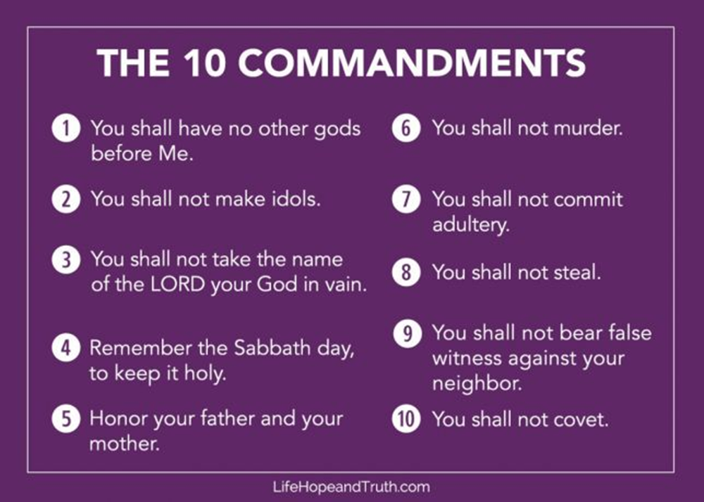
These truly are a moral guide for us to live according to. All but the 4th commandment are repeated in the New Covenant and at the very least the Sabbath Day commandment is a creation ordinance that reminds us that God ordained for us to set aside one day of rest every seven days.
Whether you are a Christian or not, repeatedly and unrepentantly breaking these moral laws will take a toll on your life. This is universal.
But as I shared last week, there is no one who has followed these commandments completely. And Jesus made them even deeper in His sermon on the mount. This is why God established a New Covenant, one that could bring glorious life instead of being a ministry of death. As the book of Hebrews records:
8 Now the main point of what we are saying is this: We do have such a high priest, who sat down at the right hand of the throne of the Majesty in heaven, 2 and who serves in the sanctuary, the true tabernacle set up by the Lord, not by a mere human being.
3 Every high priest is appointed to offer both gifts and sacrifices, and so it was necessary for this one also to have something to offer. 4 If he were on earth, he would not be a priest, for there are already priests who offer the gifts prescribed by the law. 5 They serve at a sanctuary that is a copy and shadow of what is in heaven. This is why Moses was warned when he was about to build the tabernacle: “See to it that you make everything according to the pattern shown you on the mountain.” 6 But in fact the ministry Jesus has received is as superior to theirs as the covenant of which he is mediator is superior to the old one, since the new covenant is established on better promises.
7 For if there had been nothing wrong with that first covenant, no place would have been sought for another. 8 But God found fault with the people and said:
Hebrews 8:1-8 NLT
Notice it wasn’t God’s law that was at fault, it was God’s people who couldn’t show the glory of God’s law. So established something new that made the old obsolete.
“The days are coming, declares the Lord,
when I will make a new covenant
with the people of Israel
and with the people of Judah.
9 It will not be like the covenant
I made with their ancestors
when I took them by the hand
to lead them out of Egypt,
because they did not remain faithful to my covenant,
and I turned away from them,
declares the Lord.
10 This is the covenant I will establish with the people of Israel
after that time, declares the Lord.
I will put my laws in their minds
and write them on their hearts.
I will be their God,
and they will be my people.
11 No longer will they teach their neighbor,
or say to one another, ‘Know the Lord,’
because they will all know me,
from the least of them to the greatest.
12 For I will forgive their wickedness
and will remember their sins no more.”
13 By calling this covenant “new,” he has made the first one obsolete; and what is obsolete and outdated will soon disappear.
Hebrews 8:8-13 NLT
This New Covenant brings about a new mind, new heart, and new awareness of who God is. And because it was necessary, God forgave them of their sins and chooses to “remember their sins no more.” This New Covenant is for Jew and Gentile alike. And the deal was ratified by Jesus’ sacrifice as our Great High Priest.
10 The law is only a shadow of the good things that are coming—not the realities themselves. For this reason it can never, by the same sacrifices repeated endlessly year after year, make perfect those who draw near to worship. 2 Otherwise, would they not have stopped being offered? For the worshipers would have been cleansed once for all, and would no longer have felt guilty for their sins. 3 But those sacrifices are an annual reminder of sins. 4 It is impossible for the blood of bulls and goats to take away sins.
5 Therefore, when Christ came into the world, he said:
“Sacrifice and offering you did not desire,
but a body you prepared for me;
6 with burnt offerings and sin offerings
you were not pleased.
7 Then I said, ‘Here I am—it is written about me in the scroll—
I have come to do your will, my God.’”
8 First he said, “Sacrifices and offerings, burnt offerings and sin offerings you did not desire, nor were you pleased with them”—though they were offered in accordance with the law. 9 Then he said, “Here I am, I have come to do your will.” He sets aside the first to establish the second. 10 And by that will, we have been made holy through the sacrifice of the body of Jesus Christ once for all.
Hebrews 10:1-10 NLT
The knowledge of this New Covenant and Jesus’ work changes the way we see God’s law. It changed it so much that Paul even called it by a different term. The Law of Christ or the Law of Love.
6 Brothers and sisters, if someone is caught in a sin, you who live by the Spirit should restore that person gently. But watch yourselves, or you also may be tempted. 2 Carry each other’s burdens, and in this way you will fulfill the law of Christ. 3 If anyone thinks they are something when they are not, they deceive themselves. 4 Each one should test their own actions. Then they can take pride in themselves alone, without comparing themselves to someone else, 5 for each one should carry their own load.
Galatians 6:1-5 NLT
This is not a Jewish law. As I said before, it is for Jew and Gentile alike.
19 Though I am free and belong to no one, I have made myself a slave to everyone, to win as many as possible. 20 To the Jews I became like a Jew, to win the Jews. To those under the law I became like one under the law (though I myself am not under the law), so as to win those under the law. 21 To those not having the law I became like one not having the law (though I am not free from God’s law but am under Christ’s law), so as to win those not having the law. 22 To the weak I became weak, to win the weak. I have become all things to all people so that by all possible means I might save some. 23 I do all this for the sake of the gospel, that I may share in its blessings.
1 Corinthians 9:19-23 NLT
Some people want to keep living according to the
“Do what is right and you will have God’s blessings principle in life.”
Which may be true in a very general, proverbs kind of way. Only problem is that in that economy it only takes one transgression to inherit the curse of death. Christ loved us and laid His life down for us so that we could live without the fear of the curse. It is this love that sums up all of the moral commands.
…an expert in the law, tested him with this question: 36 “Teacher, which is the greatest commandment in the Law?”
37 Jesus replied: “‘Love the Lord your God with all your heart and with all your soul and with all your mind.’ 38 This is the first and greatest commandment. 39 And the second is like it: ‘Love your neighbor as yourself.’ 40 All the Law and the Prophets hang on these two commandments.”
Matthew 22:35-40 NLT
If love of God and love of neighbor is what all the law and prophets hang on, then we would be wise to apply God’s law through the lens of love. What is it?
4 Love is patient, love is kind. It does not envy, it does not boast, it is not proud. 5 It does not dishonor others, it is not self-seeking, it is not easily angered, it keeps no record of wrongs. 6 Love does not delight in evil but rejoices with the truth. 7 It always protects, always trusts, always hopes, always perseveres.
8 Love never fails. But where there are prophecies, they will cease; where there are tongues, they will be stilled; where there is knowledge, it will pass away. 9 For we know in part and we prophesy in part, (We fulfill the law in part, my addition)10 but when completeness comes, what is in part disappears. 11 When I was a child, I talked like a child, I thought like a child, I reasoned like a child. When I became a man, I put the ways of childhood behind me. 12 For now we see only a reflection as in a mirror; then we shall see face to face. Now I know in part; then I shall know fully, even as I am fully known.
13 And now these three remain: faith, hope and love. But the greatest of these is love.
1 Corinthians 13:4-13 NLT
Let me rephrase this a bit, because if the law and the prophets hang on love let’s substitute love with obedience to God’s moral commands.
Obedience to the law of Christ is patient, obedience to the law is kind. It does not envy, it does not boast, it is not proud, it does not dishonor others, it is not self-seeking, it is not easily angered, it keeps no record of wrongs. Obedience does not delight in evil but rejoices with truth. It always protects, always trusts, always hopes, always perseveres.
I say this because Old Covenant Law (the law that was written on tablets of stone) put people to death, even for failing to keep one day holy.
We, as believers in the New Covenant, obey and hold people to obedience with hearts that have been softened by our spiritual conversion. A spiritual conversion that crushed our rock hard hearts efforts to achieve glory through our efforts. Instead, it is our love for God’s love for us that helps us see the glory of God in our lives and the lives of others. As we have already learned in 2 Corinthians 3:
4 Such confidence we have through Christ before God. 5 Not that we are competent in ourselves to claim anything for ourselves, but our competence comes from God. 6 He has made us competent as ministers of a new covenant—not of the letter but of the Spirit; for the letter kills, but the Spirit gives life.
2 Corinthians 3:4-6 NLT
The Old Covenant Law crushes people. The Law of Christ has the same moral code, but it is lived out by people who have buried any notions of their own glory and exchanged it to inherit God’s glory through Christ.
14 For those who are led by the Spirit of God are the children of God. 15 The Spirit you received does not make you slaves, so that you live in fear again; rather, the Spirit you received brought about your adoption to sonship. And by him we cry, “Abba, Father.” 16 The Spirit himself testifies with our spirit that we are God’s children. 17 Now if we are children, then we are heirs—heirs of God and co-heirs with Christ, if indeed we share in his sufferings in order that we may also share in his glory.
18 I consider that our present sufferings are not worth comparing with the glory that will be revealed in us. 19 For the creation waits in eager expectation for the children of God to be revealed.
Romans 8:14-19 NLT
If living the letter of the law was like a 1958 Cooper T43, then living according to the spirit of the law is like is like driving the newest F1 car that money can buy. And that experience is still only a part of what glorious things will come in the future.

